1

Formation and Dissolution of Phase Separated Structures in Ultrathin Blend Films (Summary)

**Chemical Process**

* Intro to Blended Polymers
* Polymer blends often exhibit more desirable characteristics than its homopolymer counterparts
* Most blends demix due to incompatibility, and the resulting morphology is greatly affected by the degree of separation
* Understanding the mechanisms and kinematics behind the resulting morphology may prove beneficial to commercial interests requiring these blended polymers
* Florry-Huggins Theory

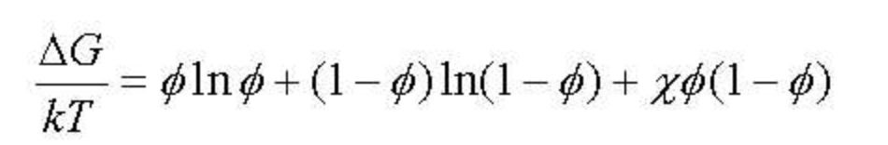

* System desires to minimize free energy, driving phase separation
* The Flory-Huggins Parameter (*χ*) is a function of both temperature and composition (polymer concentration), measuring monomer-monomer interaction
* First two terms are entropy of fixing and the last term is the heat of mixing (enthalpy)
* the increase in entropy from mixing the two components together is drastically reduced in polymers due to the decrease of the number of possible monomer configurations
* increasing the number of repeat units in the polymer (increasing molecular weight) will decrease the entropic contribution to the free energy, allowing the quadratic enthalpy term to dominate and create two minimums in the Gibbs free energy
* the preparation substrate and vacuum-film interface introduce substrate energy and surface tension as dominant variable in phase separation

According to experimental findings, three behaviors are observed:

1. In some cases, χ increases greatly with polymer concentration. This is often the case for poor solvents.

2. In some other cases, χ is nearly independent of composition, as predicted by the original Flory-Huggins theory, which is often the case for good solvents.

3. In a very few cases, χ decreases with increasing polymer concentration. This behavior is sometimes observed for polymer-solvent systems that are highly exothermal.

2

* Films are spun cast onto silicone substrate, annealed in vacuum for various times

**Polymer Blend Applications**

* **Semiconductor device fabrication** is used to create the integrated circuits that are present in everyday electrical and electronic devices.
* **Alloys** in automotive and aviation vehicle parts and supplies.
* **Biocompatible polymer blends**, such as alginate blends, have a widespread use in pharmaceutical and medical applications due to their specific features, such as biodegradation, adhesiveness, and thermo‐ and pH sensitivity and that can be obtained from the mixture composition.

**50/50 PS/PMMA Results**

* Initial spin casting produces a PMMA continuum with PS domains which, upon annealing (2 minutes) subsequently rearrange into domains much smaller than those originally formed.
* When washed with cyclohexane to remove the PS, 20% of the PS was retained after washing, indicating that the PS domains were not completely phase separated
* As the PS domains increased in size, they experience the lateral roughness of the PS-PMMA interface

Figure 1. **50/50 PS/PMMA (27k/27k) spun onto silicon surfaces, annealed in vacuum at 180 C**

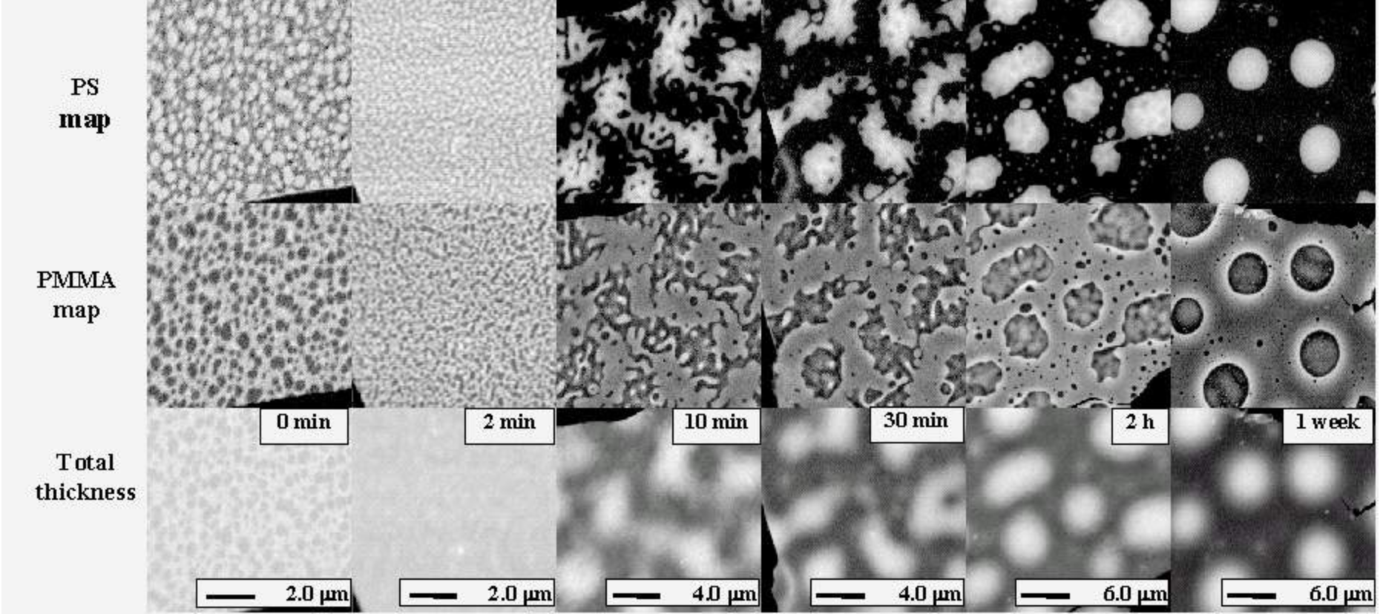

* The differences in film preparation produce very different initial morphologies.
* Initial movement of the phase separated regions is not a simple coalescence into larger, separated domains but instead a "bursting" into smaller regions.  The bursting effect is

3

* more pronounced with higher temperature.   Later stages yield intricate PS-PMMA interfacial fluctuations due to resonant capillary wave effects.  In the latest stages, all three systems exhibit coarsening of the domains as the system is minimizing the high energy PS-PMMA interface by becoming more rounded.

**3D Reconstruction**

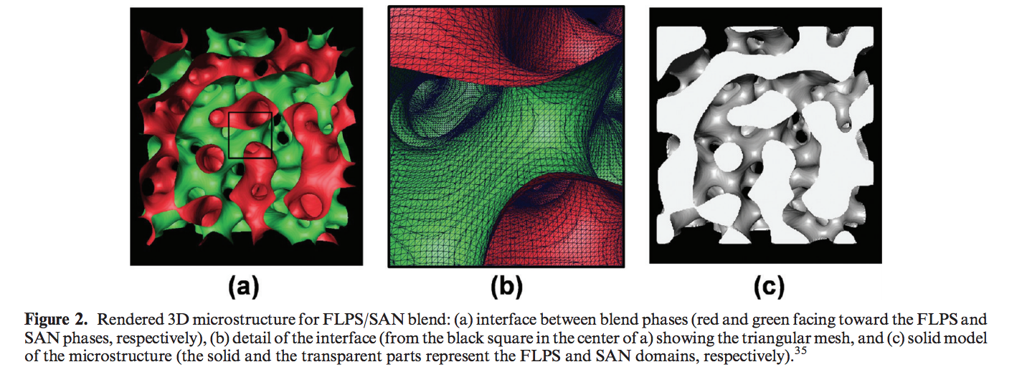

4

* semiautomatic serial sectioning technique to obtain optical micrographs of different sections and reconstruct the 3D microstructure of Pb-Sn alloys
* coordinate transformation (CT) method was applied to measure the local curvature of the interface of an immiscible polymer blend made of fluorescently labeled polystyrene (FLPS) and styrene-ran-acrylonitrile copolymer (SAN).
* quantify the topology evolution of the blends during coarsening
* the probability densities of the curvatures at various times were successfully scaled by a time-dependent characteristic length, i.e., interface area per unit volume (Q)
* The 2D sliced images collected with LSCM were processed to reduce image degradation produced by noise and blurring.
* Out-of-focus blur was reduced by applying a deconvolution technique